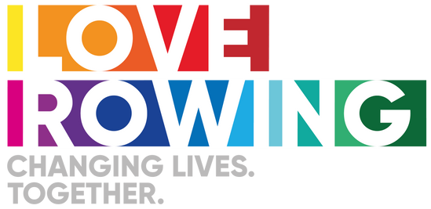
Love Rowing Open Grant Round Guidance

Tips to support applications targeting young people from ethnically diverse communities

Rowing is a sport that is currently not representative of the diverse communities in UK society. We want to change that. More needs to be done to ensure that rowing is accessible to ethnically diverse communities and that positive experiences of participating in rowing are delivered. This isn’t just about rowing - the proportion of people that meet the recommended levels of physical activity from ethnically diverse backgrounds is significantly lower than the national average, and 2 in 5 people from ethnically diverse communities felt they have fewer opportunities to participate in sport and physical activity than someone from a white background.
If you're a rowing club, the first step is gaining insight that your club membership is not representative of your local community, and work out a programme with solutions to tackle the underlying issues for the underrepresentation.
If you are a community organisation or school representing ethnically diverse communities, consider how you can work in partnership with a rowing organisation to create new sustainable rowing opportunities.
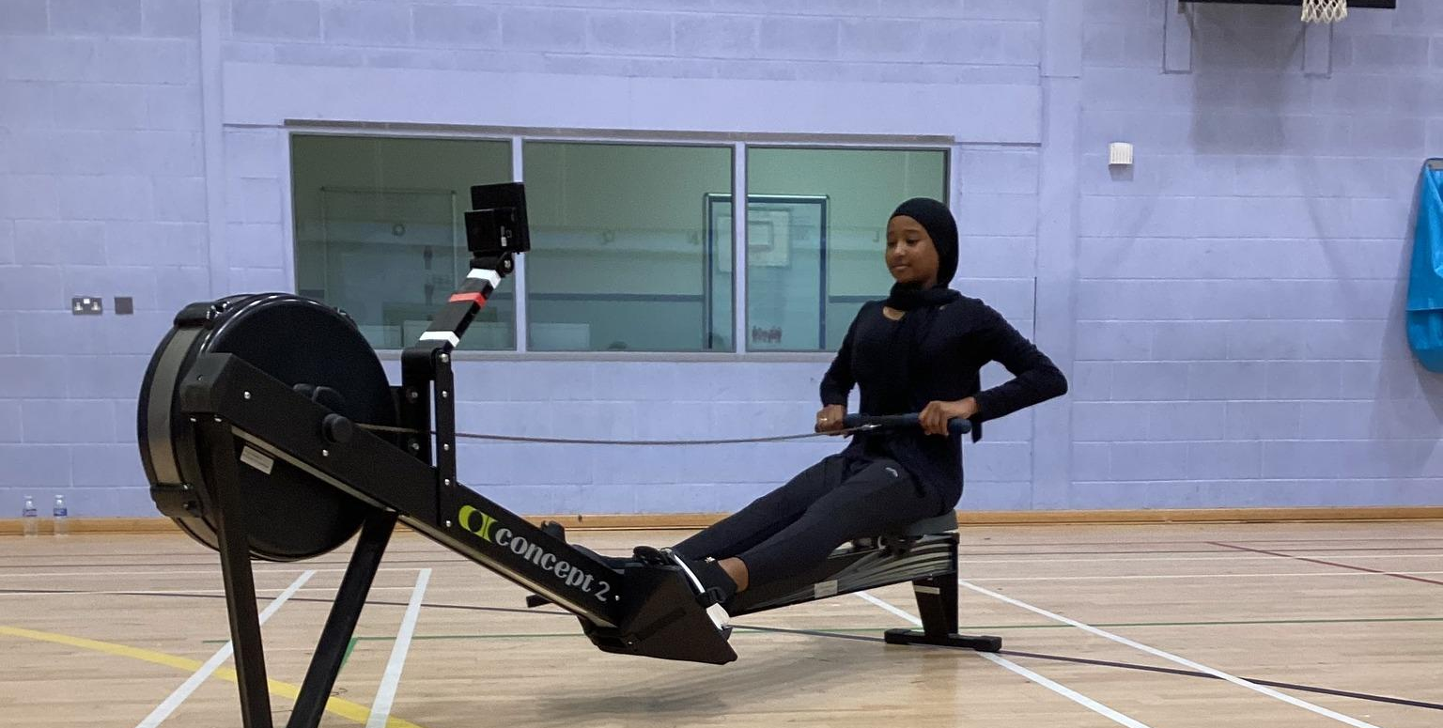
Understanding barriers facing ethnically diverse communities accessing rowing.
If your project aims to reach and support ethnically diverse communities to row, you need to consider the barriers they are likely to face in accessing rowing. We are looking for projects with creative and co-created solutions that reach new people from ethnically diverse communities and keep them rowing.
Barrier 1: Lack of diversity
The lack of visible diversity amongst participants, coaches and volunteers often discourages people from ethnically diverse backgrounds to get involved, as an organisation can be perceived as ‘non-welcoming’ or not understanding of the different ethnic community groups, their culture and their behaviours. English may also not be the first language for many ethnically diverse communities so they may not feel comfortable joining your organisation or even know about how to join.
Solutions that work:
Engage and consult with current participants and volunteers from ethnically diverse communities or local faith leaders or other local groups to identify specific needs, wants and any barriers that might stop people from ethnically diverse communities getting involved.
Promote role models and use diverse imagery or people from ethnically diverse communities rowing, coaching or volunteering in your promotional materials and communications. Reach out and promote the offer in places where ethnically diverse communities already meet such as local community groups or faith centres. Focus on the health and social benefits of participating rather than competition. Promote your organisation's commitment to the inclusion of everyone in rowing.
Check it out: Love Rowing facilitated a link between Sunderland Rowing Club and the International Community of Sunderland (ICOS) to create and promote an inclusive offer to the local refugee community. ICOS were critical in understanding how to reach the target audience and understanding their needs. The club listened and flexed to meet their needs.
Barrier 2: Programming and logistics of activity
Women from particular ethnic groups and faiths will not want to participate in activities with men or will be reluctant if men are present. Furthermore, a lack of privacy in changing, showering and activity areas can be a barrier for some ethnic groups and faiths.
For some groups offering activities at certain times or on specific days may be a barrier particularly if these are offered at times of prayer or worship or holy days.
The kit people wear when participating in rowing can be a barrier for both males and females of particular ethnic or faith groups.
Solutions that work:
Ensure your activity offer, programming and facilities are inclusive, this can include:
- Connect with other local groups who have a reputation for being inclusive and meeting the needs of ethnically diverse communities to seek their advice on running and adaptive sessions. This can help those from ethnically diverse communities to feel more comfortable and confident to attend your sessions.
- Provide regular taster sessions in partnership with a local community or faith group, but ensure the participants also know the club is open, friendly and welcoming to everyone.
- Flexibility around kit and sporting clothing.
- Consider offering activities for different genders.
- Consider the timing of your offer. Speak to your members, volunteers or local faith leaders and trusted organisations to find out what works best for them.
Love Rowing previously funded Fairlop Rowing Club & 310 Fitness set up 6-week taster sessions in partnership with Muslimah Sports Association to introduce female Asians to rowing. It was extremely popular with extra sessions added to meet demand.
Barrier 3: Experience of racism and racial stereotypes

Previous experiences of racism within sport can negatively impact future participation. Furthermore, throughout society particular stereotypes have been associated with different ethnic groups. This is a form of discrimination and can also negatively impact participation.

Solutions that work:

Making sure your organisation's operations are underpinned by inclusive practices and procedures can be valuable in creating a more welcoming and inclusive environment for people from ethnically diverse backgrounds. This includes having an up to date equality and diversity policy, shouting about your equality statement on your website and social media, and developing an anti racism and discrimination policy with clear reporting procedures. Provide education for all coaches and volunteers in line with these policies. Proactively tell everyone your goals to attract and recruit new members from ethnically diverse backgrounds.

If you are a community organisation representing ethnically diverse communities, can you partner with rowing clubs and organisations to create a project that helps us to change perception and tackle racial stereotypes?

Check out IBELONG AT THE LEA ROWING CLUB who are driven to change the diversity of rowing: https://www.learc.org.uk/ibelong

Examples of project ideas or things we might consider funding based on our learnings so far:
- Rowing outreach programmes into state schools, holiday programmes and with community organisations in areas with high populations of ethnically and culturally diverse communities.
- New culturally sensitive rowing programmes such as gender specific sessions, sessions at appropriate times and with the provision of appropriate clothing. We would like to see that this is driven by community consultation.
- Training for coaches and volunteers.
