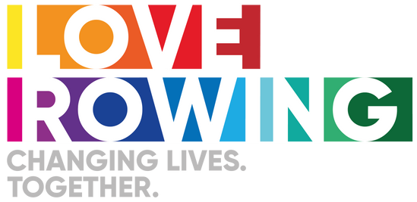
Love Rowing Open Grant Round Guidance

Tips to support applications targeting young people from low socio-economic backgrounds

Low socioeconomic status (SES) is a way to describe people who have less access to resources like education, income, and health care than others with a higher SES. There are various ways to measure this income, wealth, education and occupation.

We are not expecting an organisation wanting to deliver a rowing project to know this in depth, but here are a couple of fairly easy ways to understand how you can reach young people who are more likely to fit into this category of low socioeconomic status and who therefore face financial and multiple disadvantages to accessing rowing.

The easiest way is to assess if the club, school, activity, or community are located in an area of multiple deprivation. Multiple deprivation is a relative measure of how deprived a person or area is, based on a combination of factors: income, employment, education, health, crime, barriers to housing and services, and living environment. Here are a couple of useful web based tools to assist you to understand the deprivation levels of an area. We would be looking to support the most deprived areas:

Wales: https://wimd.gov.wales/
England: https://www.fscbiodiversity.uk/imd/
Scotland: https://simd.scot/#/simd2020/BTTTFTT/9/-4.0000/55.9000/
Northern Ireland: https://www.nisra.gov.uk/news/new-ni-multiple-deprivation-measures-2017-lookup-tool

Another option is to target schools who have a higher percentage of young people who are financially disadvantaged. Talk to your local schools and search for data online. Schools that access government funding to reduce the poverty attainment gap have a high number of young people who are financially disadvantaged. This is how it works:

The pupil premium grant is funding to improve educational outcomes for disadvantaged pupils in state-funded schools in England. Pupil premium is not a personal budget for individual pupils. Pupils that are defined as disadvantaged by the following criteria:
- pupils who are recorded as eligible for free school meals, or have been recorded as eligible in the past 6 years
- children previously looked after by a local authority or other state care, including children adopted from state care or equivalent from outside England and Wales
The Pupil Development Grant (PDG) is the equivalent to the Pupil Premium in Wales. There isn’t a direct equivalent to pupil premium in Scotland, however the Pupil Equity Funding (PEF) is allocated directly to schools to help close the poverty-related attainment gap.
It will strengthen your application if you already have identified and confirmed the partnership with any schools you plan to work with, if this is part of your project idea.
Another way to understand the socio economic background of your target audience is to consider household income although this is often more difficult for voluntary or community organisations to navigate. Consideration of unemployment or if the main occupation of the parents or guardians of young people are categorised by the National Statistics Socio-economic Classification (NS-SEC) groups 5, 6, 7, and 8. NS-SEC 5 refers to people in intermediate occupations, such as shopkeepers, paramedics, and small business owners, NS-SEC 6-8 refers to people in lower supervisory and technical occupations, such as plumbers, gardeners, and semi-routine and routine occupations, such as shop assistants and bus drivers. Alternatively you could consider if the family has access to benefits. A family must have claimed Child Benefit and at least one other household benefit (Universal Credit, tax credits or Housing Benefit) at any point in the year to be classed as low income.
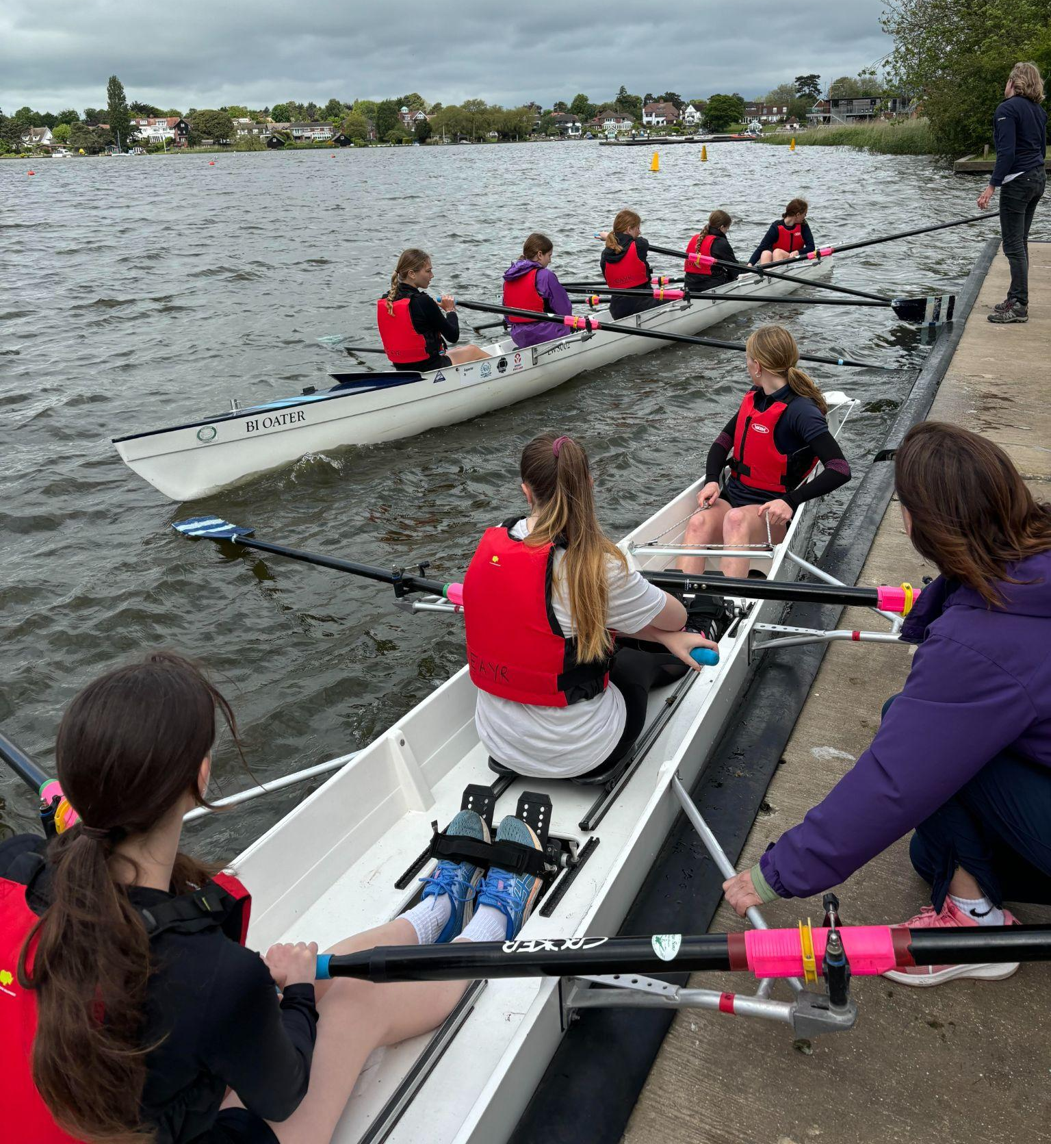
Understanding barriers facing young people from low income groups
If your project aims to reach and support young people from low socio economic backgrounds you need to consider the barriers they are likely to face in accessing rowing, and ensure your project finds solutions to those barriers.
Barrier 1: A lack of disposable income.
If someone is from a low income household they are likely to have to prioritise how they spend their money. This would impact their capacity to buy appropriate clothing, buy kit, pay for membership, costs related to attending competitions and even funding how they get to the club.
Solutions that work:
We have previously funded school projects or rowing clubs that have reached into schools to provide free rowing provision. This ensures financial barriers are not an issue when someone is getting started. Successful projects have gone that next step and funded appropriate clothing, provided transport after school to take people to the club and/or provided bursaries for young people who have parents on low income backgrounds. We can also learn from other sports and activities that apply the ‘pay what you can’ approach.
Build in ideas to your project application to ensure someone from a low income background can keep rowing.
Barrier 2: Health inequalities
Young people and their families from lower socio-economic groups are more likely to experience health inequalities. They are more likely to be physically inactive. They’re more likely to have physical and mental health conditions and therefore additional challenges and barriers to overcome.
Solutions that work:
Be inclusive from the beginning, be proactive and coach the people in front of you. When working with schools clearly state you are not targeting the sporty kids in the school, but those who would benefit the most. Find out more about the abilities and individual needs of who is going to be in the group. Consider coaching adaptations you might need as part of your project funding proposal that might assist you, this might include training for coaches or adaptive rowing equipment.
Barrier 3: Perception
Rowing is often perceived as elitist and privileged by those outside of the sport. For people from a lower socio-economic background this perception may create worries for people about being judged or feeling out of place.
Solutions that work:
Invest the time to show your local community that your club is approachable, friendly, welcoming and open to everyone. Use marketing and outreach activities to reach into your local community through schools, community days, open days and holiday activities. Work in partnership with local trusted organisations to provide outreach activities.
Barrier 4: Personal barriers
Young people from lower-socio economic backgrounds are more likely to face multiple challenges and barriers in life. For example, they may be in the care system or be young carers themselves. Their parents are also more likely to have multiple jobs or health concerns.
Solutions that work:
Consider how flexible your activity can be to meet the needs of these young people. Their progress may take longer and they might not be consistent in their attendance. They need to feel listened to, valued, feel the rowing provision is a safe place for them no matter what. Projects might consider the support of locally trusted organisations who are experienced and known in supporting young people facing multiple challenges. Coaches might need training or assign volunteers to act as support volunteers.
An example of a rowing project that does this brilliantly is the River Ayr project - check it out: https://www.instagram.com/reel/C_vAELHAKaq/?utm_source=ig_web_copy_link&igsh=MzRlODBiNWFlZA==
Examples of project ideas or things we might consider funding based on our learnings so far:
- State school rowing programmes (new or existing) that can evidence that they support young people from lower socioeconomic backgrounds and how the funding will enable those young people to keep rowing without barriers.
- Rowing clubs outreach programmes into state schools with high numbers of young people from lower socioeconomic backgrounds with clear pathways that enable the young people to keep rowing. This could include indoor rowing introductory activity, indoor rowing clubs with opportunities to take part in events, transport and free water based sessions during or after the school day, bursary schemes to encourage ongoing participation.
- A rowing club supporting a state school to form a new and sustainable rowing programme.
- Indoor rowing provision in a new youth community setting linked to a rowing club.
- Rowing activity as part of wider youth initiative, linked to a local trusted organisation or holiday programme with opportunities to keep taking part.
